Checkmate

A PROJECT REPORT

BY

TEAM NO. 35

**Beereddy Sahith Reddy** (E19CSE046)

SUBMITTED TO

DEPARTMENT OF COMPUTER SCIENCE ENGINEERING BENNETT UNIVERSITY

GREATER NOIDA, 201310, UTTAR PRADESH, INDIA

NOVEMBER 2020

# DECLARATION

I/We hereby declare that the work which is being presented in the report entitled “CheckMate”, is an authentic record of my own work carried out during the period from JUNE, 2020 to November, 2020 at Department of Computer Science and Engineering, Bennett University Greater Noida.

The matters and the results presented in this report has not been submitted by me for the award of any other degree elsewhere.

Signature of Candidate

Beereddy Sahith Reddy

(Enroll. No. E19CSE046)

# ACKNOWLEDGEMENT

I/We would like to take this opportunity to express my/our deepest gratitude to my/our mentor, **Dr. Anurag Goswami** for guiding, supporting, and helping me/us in every possible way. I/we was/were extremely fortunate to have him as my/our mentor as he provided insightful solutions to problems faced by me/us thus contributing immensely towards the completion of this capstone project. I/We would also like to express my/our deepest gratitude to VC, DEAN, HOD, faculty members and friends who helped me/us in successful completion of this capstone project. Any other name you can mentioned here.

Signature of Candidate

Beereddy Sahith Reddy

(Enroll. No. E19CSE046)

TABLE OF CONTENTS

TABLE OF CONTENTS iv

LIST OF TABLES vi

LIST OF FIGURES vii

ABSTRACT viii

1. INTRODUCTION 1

1.1. Problem Statement 1

2. Background Research 2

2.1. Proposed System 3

2.2. Goals and Objectives 4

3. Project Planning 4

3.1. Project Lifecycle 4

3.2. Project Setup 5

3.3. Stakeholders 5

3.4. Project Resources 5

3.5. Assumptions 6

4. Project Tracking 6

4.1. Tracking 6

4.2. Deliverables 7

5. SYSTEM ANALYSIS AND DESIGN 7

5.1. Overall Description 7

5.2. Design diagrams/ UML diagrams/ Flow Charts/ E-R diagrams 8

6. User Interface 9

6.1. UI Description 9

6.2. UI Mockup 10

7. Project Closure 12

7.1. Delivered Solution 12

7.2. Remaining Work 12

REFERENCES 13

LIST OF TABLES

Table Page

Tale 1: Goal and Objectives 4

Table 2: Project Decisions 5

Table 3: Stakeholders 5

Table 4: Project Resources 5

Table 5: Assumptions 6

Table 6: Tracking 6

Table 7: Deliverables 6

Table : Different type of users 7

LIST OF FIGURES

Figure Page

**No table of figures entries found.**

ABSTRACT

I have worked on project Checkmate based on Online background check using Android app. I tried my level best to come as close as possible to initial idea. My project is divided into 2 parts i.e., android app and Database. Database stores the information of criminal records and the android app is used to display the criminal record of required candidate. I tried to keep the user interface as simple as possible so that a naïve user will also be able to use the application. While working on this project I realized how difficult it is to do solo project. Mostly it was a hard time for me as there would be nobody to motivate me to get the work flowing and if I stuck up with some problem, I have a mentor to direct me and my mentor did his best job in guiding my project and coming to the deadlines, I had a lot of work to write the journal, poster, post, presentation and make a video that is very difficult in our current situation and coming to the project, with the support of some of my friends who helped a lot in documentation

1. INTRODUCTION

Many businesses are still counting on their offline background check, a manual service

established more than 40 years ago before ‘online’ turned into even a term. It’s no wonder then, that the offline background check feels clunky inside our hiring procedures today. This platform helps companies modernize their background check handle with imaginative innovation and products planned to create contracting more secure, more effective, and more comprehensive. For every one that manages talent, across nearly every business, Checkmate helps create hiring quicker, safer, and more compliant

* 1. Problem Statement

Till today many companies are using age old offline background check for verification of there

employees. Offline background checks are slow, unreliable, expensive due to interference of humans in this process.

This platform is here to replace the old offline mode of background check of an employee which is slow and inefficient. Online background checks are faster, friendlier, and more obvious for candidates. This makes the hiring system extra steady and leaves much less possibility for human bias and error.

1. Background Research

According to the survey conducted by the National Association of Professional Background Screeners (NAPBS) asking over 2000 HR professionals on employment, background checks 95% of the answerer claimed that to have employment screening. when they were asked why they have conducted employment background checks 52% of answerer said the wanted to improve the quality of employees,38% of answerer said that they wanted to protect the company reputation,36% percent answerers said they wanted to reduce and prevent theft and other criminal behavior. by the National Association of Professional Background Screeners proves that checks are universal. Nearly 98% of HRs think that accuracy in background checks important.at the same time, they also want the length of time it takes to get results of the screens which is the challenging part1

Work environment security and security is all over the news these days. So, it’s not shocking that, at a time when working environment shootings and other shapes of viciousness are getting to be more predominant, employers cited security as the top reason they conduct foundation checks. A full 89 percent expressed they conduct foundation checks to secure workers, clients, and others within the work environment.

Things that employers do as part of background check

1)national Criminal database search

2)Education Verification

3)Driving history check

4)drugs and alcohol check

5)sex offender Registry

In 2019 Employers background screening survey conducted by Preemploymentdirectory.com

The question was what are the main challenges that are faced during the current way of background checking. The Most Common answers were ‘Timeliness’ and ‘Cost’. This survey suggested that “old and offline mode of background checks should be replaced with new technological solutions should be replaced with new technological solutions to enable them to quickly process the background checks and reduce the overall cost of operations to manage cost pressures in the market place”. Another question was why wanted to conduct a background check on their employees. The most common answer was ‘It Ensures Workplace Safety’ (Thomas Ahearn, 2019)

* 1. Proposed System

The aim of this project is to make this system universal for every employee in India. In short, every employee should have a mandatory profile regarding their background check which should have their criminal record, etc. I would link to Aadhar card to this system so that it would be an easy search for a background check report of an employee. Helps in reducing the risk and keep compliance. Checkmate makes employing quicker, more secure, and more agreeable across pretty much every business

* 1. Goals and Objectives

My goal is developing an app as prototype for my proposed system by making a sample database of background checks and an android application view the search results. My Future goals are (Technical goals)-

1)To make actual database of real background reports

2)Ability to see past searched profile

3)The person whose background report is being checked should be notified through SMS.

Tale 1: Goal and Objectives

|  |  |
| --- | --- |
| **#** | **Goal or Objective** |
| 1 | Make the system extensible – future updates like ability see past searches can be done easily |
| 2 | Make the system easy to support – provide good documentation, configuration/build files, administrator’s manual |
| 3 | Make the system very easy to use – users would agree that minimal to no training is needed |
| 4 | Have fun working on the project |

1. Project Planning
   1. Project Lifecycle

According to the Project Management Institute, the project life cycle is critical for any managers hoping to deliver projects to clients successfully.2

In my project there were 4 phases –

1) Conceptualization – I started to conceptualize the Idea of universal online background check, how this will be advantageous our offline background checks.

2)Planning-Earlier I thought of making a website, but Later changed my mind to make an android app and will use MySQL as database.

3)Execution-First I learned some basics of android studio and started to develop the app.

4)Termination-Checked if a have achieved which I had made in conceptualization phase and ended the project.

* 1. Project Setup

Table 2: Project Decisions

|  |  |
| --- | --- |
| **#** | **Decision Description** |
| 1 | Website vs android app vs IOS app.-finally chose android app. |
| 2 | MySQL vs SQL vs Microsoft SQL Server-finally chose MySQL |
| 3 | Use Firebase Console for authentication of users |

* 1. Stakeholders

Table 3: Stakeholders

|  |  |
| --- | --- |
| **Stakeholder** | **Role** |
| Sahith Reddy | Team member |

* 1. Project Resources

Table 4: Project Resources

|  |  |  |
| --- | --- | --- |
| **Resource** | **Resource Description** | **Quantity** |
| Database Server | A database server | 1 |
| App development Software | Android Studio is being used as an IDE for writing Code | 1 |
| Mohammad Atif | The mentor who will be able to provide us with technical assistance. | 1 |
| Windows Laptop | A Windows laptop for development of Application on android studio | 1 |
| Android Phone | An Android phone to be used as test hardware for the mobile version of the software. | 1 |

Assumptions

Table 5: Assumptions

|  |  |
| --- | --- |
| **#** | **Assumption** |
| A1 | mentors will be able to meet face to face once a week. |
| A2 | Firebase available for work with as a trial for the 6 months of the project. |
| A3 | I will be able to familiarize myself with the Android Studio, Firebase, and MySQL |
| A4 | I will have sufficient time to complete a working model to present by end-semester |
| A5 | I will be able to design sample database. |

1. Project Tracking
   1. Tracking

Table 6: Tracking

|  |  |  |
| --- | --- | --- |
| **Information** | **Description** | **Link** |
| Code Storage | Project code will be stored in GitHub repository. | Link |
| Project Documents and Assignments | Weekly reports, specification, and design documents, etc. will be stored in our GitHub repository. | Link |

* 1. Deliverables

Table 11: Deliverables

|  |  |
| --- | --- |
| **#** | **Deliverable** |
| 1 | Working Application |
| 2 | Code |
| 3 | Install process documents |
| 4 | Final report (final PowerPoint presentation, 5-minute video) |

1. SYSTEM ANALYSIS AND DESIGN
   1. Overall Description

My project is attempt on developing a universal Background check System, I started with making an android app. First the user needs to create an account in order to keep track of the user.

Then the user need enter the details like name, phone number, designation which are stored in firebase real-time database. The user needs a special number called Social security number in order to search the background report. This will a lot more efficient than age old way of background checking.

I used MySQL to design the Database as of now it has 3 important tables namely criminal, crime, jail. With the help of JDBC the android app in Connected to MySQL Server. criminal table has data about the person who has committed the crime. crime table has details of the Case. Jail has details of the jail in which criminal was kept.

Table 12: Different type of users

|  |  |
| --- | --- |
| **User** | **Description** |
| Developer | A team member who is tasked with managing the test data, creating initial Testing models, and ultimately generating a firm process for applying these techniques to future user data. |
| DBA (Database Administrator) | An administrator who manages and maintains Database. |
| End-user | An end user is employee of company responsible for background checking |

* 1. Flow Charts/ E-R diagrams

**3Database ER diagram**

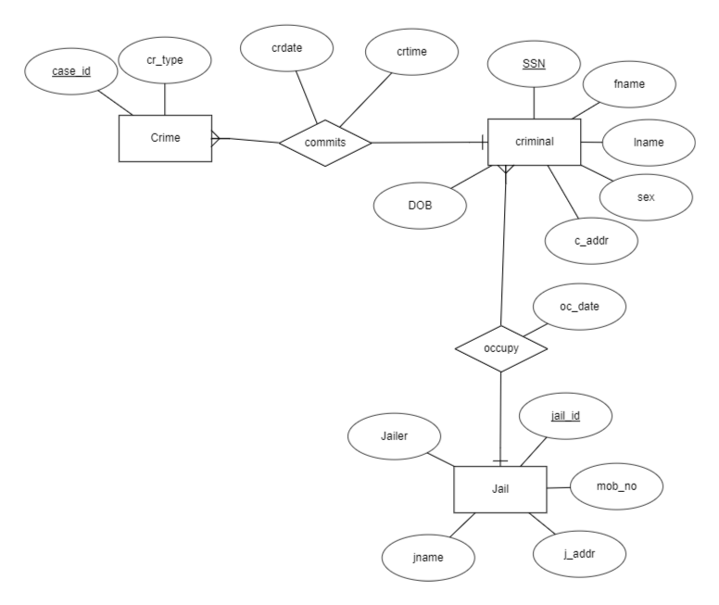

**Application Flowchart** 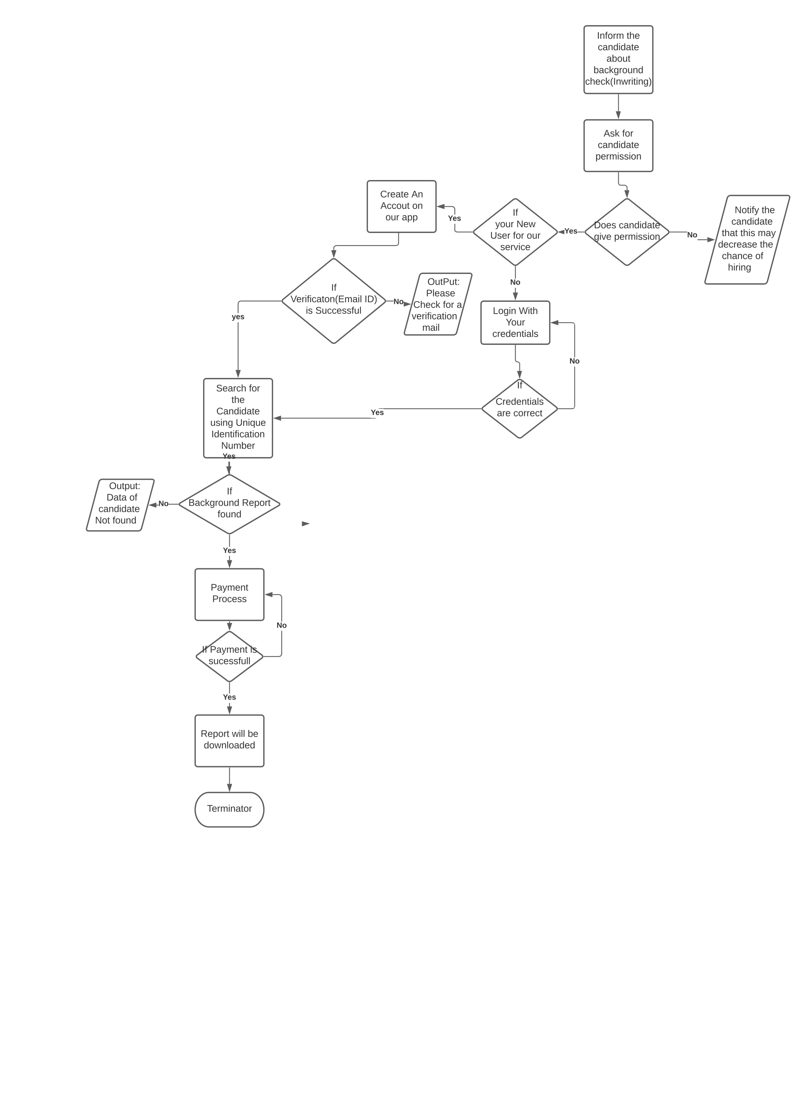

1. User Interface
   1. UI Description

The layout plan is the same all through the app. The adjusted edges of distinctive pieces are displayed on each page. The white spaces are situated in a way that the app does not seem clustered. The paddings, shifting, and framings are adjusted in a way that does not irritate the straight layout. The unique and varied features of the app have made it possible to create an interface that inherits the above characteristics.

* 1. UI Mockup

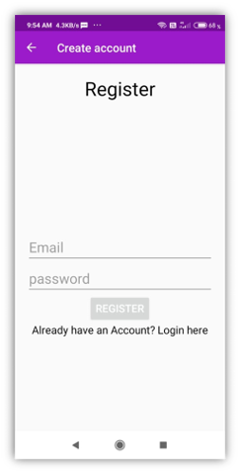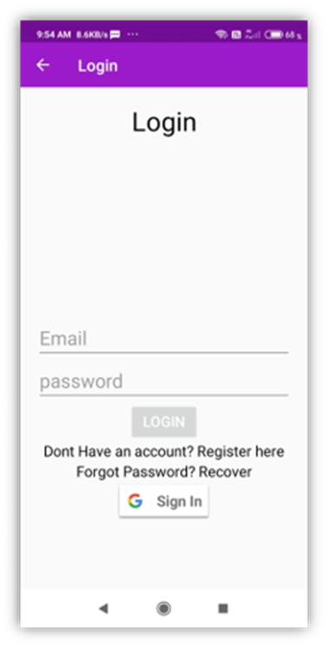

* 1. 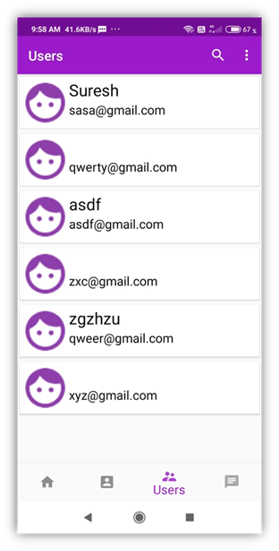UI Mockup

Project Closure

This section elucidates the overall lookup at the project and some of the future works that may enhance the solution.

* 1. Delivered Solution

The Current app is only a prototype with the Correct database the full potential of the app will be shown. Now with the current sample database when a user searches for SSN the user will get the details of stored in database to that SSN. Both the details of the user and result will be updated on database. The user has ability to update personal details.

* 1. Remaining Work

My future Goal are to make website and an IOS application for the same purpose as mention above. Addition of payment methods for purchasing Background report. Currently, I am thinking of using third-party payment methods for the transaction. Giving users ability to see their past searches and make an actual database with real information. My work will be focused to make this system universal for every employee. In short, every employee should have a mandatory profile regarding their background check which should have their criminal record, etc.

REFERENCES

1. Muderedzwa M. The Impact of IT in Employment Screening. In: *Mosharaka International Conference on Communications Networking and Information Technology*. ; 2008.

2. Project Management Institute. *A Guide to Project Management Body of Knowledge*.; 2008.

3)

# Bibliography

Thomas Ahearn. (2019, october 3). Retrieved from esrcheck.com: https://www.esrcheck.com/wordpress/2019/10/03/2019-employers-background-screening-survey/